Home Work Music: Oracle SQL Class

Table of Contents

Contents

1. Homework Music: Instructions 2

ORDER OF OPERATIONS 2

2. Homework Music: ER Diagram 3

3. Homework Music: Confirmation 4

# Homework Music: Instructions

Create the tables for this homework in your student schema

## ORDER OF OPERATIONS

When creating tables

1. Create the parent table first (if more than 1 then either one)
2. Create the primary key on the parent table(s)
3. Create the child table
4. Create the primary key on the child table
5. Create the foreign ley on the child that points to the primary key on the parent(s)

When adding data

1. Add the parent records first (if more than 1 parent then either one)
2. If more than one parent exists add the next parent record next
3. Then add the child record using the primary key values from parent/parents

When deleting data

1. Delete the child record first
2. Then you can delete one or more parents if you need to in whichever order you like

# Homework Music: ER Diagram

Artist is parent to Song

Song is child to Artist

Song is parent to Track

Album is parent to Track

Track is child to Song

Track is child to Album

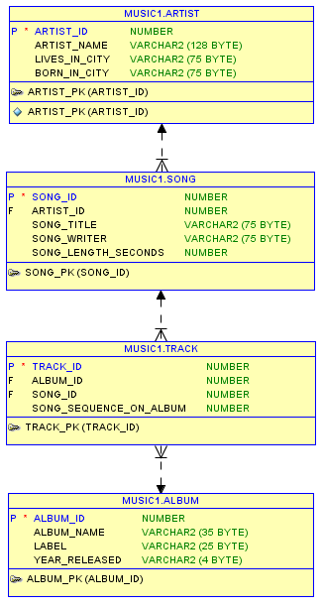

one to many

one to many

one to many



# Homework Music: Confirmation

Create tables and constraints as discussed above.

Insert the data from **SQL HW 3 Data and Notes.xls**

**Insert the data for 1 your own albums.**

Run the following queries and snip them into a word document. Email me the HW_Music_Confirmation.doc.

-- ---------------------------------------------------

-- Homework Music: Confirmation

-- ---------------------------------------------------

-- SQL No. 1 Question. List the artist’s names

select user, sysdate, artist_name

from artist;

-- Snip this and results into word doc

-- ---------------------------------------------------

-- SQL NO 2.Question. List the song titles and artist's name for every

-- song you have and sort the list by song title

select user, sysdate, artist_name, song_title

from artist ar, song s

where ar.artist_id = s.artist_id

order by song_title;

-- Snip this and results into word doc

-- ---------------------------------------------------

-- SQL NO. 3. List the album name and song titles for each album

-- and sort by album_name

select user, sysdate, album_name, song_title

from song s, track t, album al

where s.song_id = t.song_id

and t.album_id = al.album_id

order by album_name;

-- Snip this and results into word doc

-- ---------------------------------------------------

-- SQL NO. 4. Question. You are trying to decide if you want to

-- buy another album from an artist you already have

-- in your collection.

-- So list artist_name, album_name, song_title for every album

-- you have for your artist.

select user, sysdate, artist_name, album_name, song_title

from artist ar, song s, track t, album al

where ar.artist_id = s.artist_id

and s.song_id = t.song_id

and t.album_id = al.album_id

and artist_name = 'Your Artist Here';

-- Snip this and results into word doc